**Cloth/Fabric Face Masks Usage**

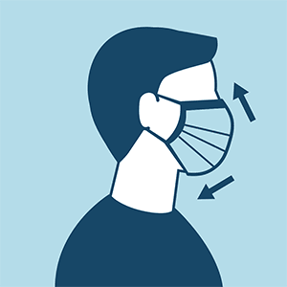

**\*\*\*\*Wash your Hands before applying Face Mask\*\*\*\*\*\***

**\*\*\*Ensure Facemask is Sanitized (See cleaning instructions below) before applying at beginning of shift\*\*\***

**When you put on the mask, make sure it covers your nose and mouth and fits comfortably around your face**

* fit snugly but comfortably against the side of the face
* be secured with ties or ear loops
* include multiple layers of fabric
* allow for breathing without restriction
* While you have the mask on in public places, avoid touching it and replace it if it feels damp.
* Even if you are wearing a face covering, though, you should exercise the same caution as if you weren’t wearing one: Stay at least 6 feet away from other people.
* Face masks should not be shared between people or worn at from one site to another

**Removing Face Mask**

* When you're done with the mask, or replacing it with a new one, carefully take it off from behind or by the straps
* Put reusable cloth masks directly into the laundry or in a sealable plastic bag until they can be laundered.
* Cloth Face masks should be machine washed with hot water and dried in a dryer on high for 5-10 minutes to sanitize between uses. Avoid using Dryer Sheets.

**\*\*\*\*Wash Hands after Removing/touching Face Mask\*\*\*\*\*\*\*\***